18SIB03 BxDiff  
New quantities for the measurement of appearance

Terms of Reference of the Stakeholder Committee

**Draft**: Marek Šmíd, Alžběta Rossi, ČMI

# The general aim of this Terms of Reference

The Terms of Reference describe the purpose and confirm the scope and structure of the Stakeholder Committee.

# Purpose of the Stakeholder Committee

The stakeholder committee is the steering body of the general stakeholder community supporting controlled knowledge transfer between the EMPIR project B and the interested parties.

The particular aims of the Stakeholder Committee are:

* to collect the needs of the various interested parties and feed these into the project,
* to disseminate information regarding the progress of the project adequately and appropriately to the stakeholders and ensuring that the recommended standardized measurement procedures being developed are considering their requirements,
* to disseminate information to the user community regarding potential impact of the project and to ensure that end-user needs are accounted for in the outputs of the project,
* to ensure fruitful interaction with stakeholders representing various interests of the industry to control colour, texture, gloss and sparkle.

The Stakeholder Committee shall not be mistaken with an Advisory Committee although fruitful input is always welcome.

# Membership

The direct stakeholders of the JRP can mainly be categorised into the following groups:

* Industry that needs to control the appearance of products (e.g. automotive industry, printing manufacturers, building materials, cosmetics, virtual reality).
* Manufacturers of measurement equipment,
* Standardisation organisations,
* National and regional government bodies (regulators),
* R&D Institutions and Universities,
* Independent accreditation bodies,

The stakeholder committee is potentially open to all person/institution/company/committee related to the topic of this JRP. The candidates are accepted to the committee by impact work package leader or project co-ordinator.

# Interaction of the Stakeholder Committee with the JRP-partners

Each JRP-partner will liaise with their national stakeholders directly through own networking and inform the Stakeholder Committee via delegated persons[1](see communication flow at the end). The members of the Stakeholder Committee will regularly be informed about the progress of the deliverables on dedicated webpage with restricted access and public output of the JRP on the first note, such as publications and public guides. Moreover, the Stakeholder Committee members will be invited to participate in all possible dedicated workshops and open meetings related to the project. The costs will be minimized to travel costs, the catering and space arrangements where needed, no other fee will be required for listed stakeholders.

Interaction of the Stakeholders will also be achieved via an email mailing list (newsletter)

# Meetings

Meetings will be held at suitable events where the committee is in attendance. The Committee will meet at least two times during the project. When possible, videoconference tools are used to allow participation without travelling. The Stakeholder Committee members will be invited to attend the public part of the progress meetings.

# Active role of the Stakeholder Committee Members

The active role expected for Stakeholder Committee members comprises:

* To represent the view of the broader stakeholder community.
* To provide technical input where requested and applicable, and provide expert feedback to the JRP in line with the JRP-Protocol.
* Where it is asked and applicable, to review the achievements and outcomes of the research and development within the project in line with the JRP-Protocol.
* The presence in the stakeholder committee meetings is desirable but not obligatory. Also other ways to communicate than meetings are used. Due to the disparate nature of the stakeholder committee membership, interaction will be achieved via a central website and periodical meetings that will be held at suitable events where a quorum of the committee is likely to attend.

# Communication flow

Feedback and technical/expert input to the JRP

Creating Impact in line with the section 4.

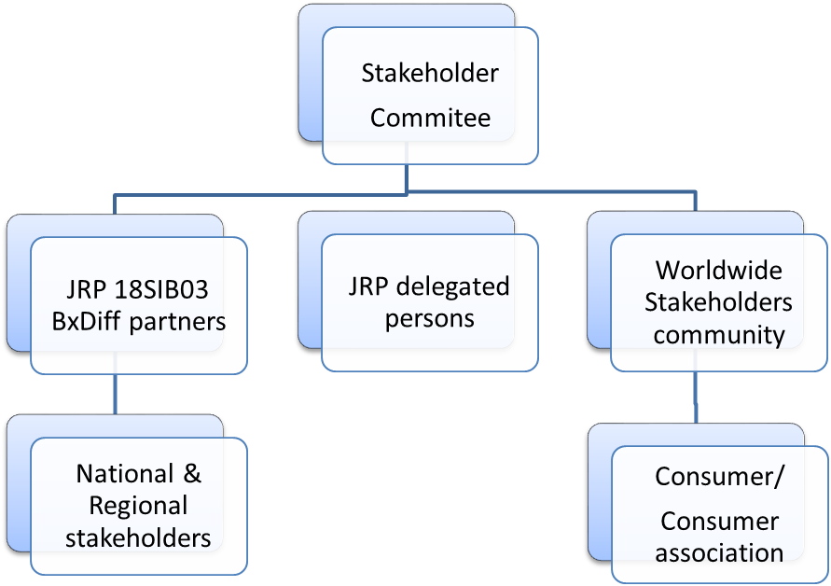

# Confidentiality

Information distributed during the project about the progress of the deliverables to the Stakeholder Committee may contain confidential and/or privileged material and cannot be distributed to other party outside the Joint Research Project.

1. The Coordinator and leader of the Creating Impact workpackage